EXPERIMENT- 12

Implementation of Virtual Private Network using Packet Tracer

By

**Madhurya Mozumder (RA1911028010036)**

Under the guidance of

**Mrs. P. Visalakshi**

*In partial fulfilment for the course*

Of

**18CSC302J- COMPUTER NETWORKS**



**FACULTY OF ENGINEERING AND TECHNOLOGY**

**SRM ISNTITUTE OF SCEINCE AND TECHNOLOGY**

Kattankulathur, Chengalpattu District

November 2021

Abstract

VPN stands for **"Virtual Private Network"** and describes the opportunity to establish a protected network connection when using public networks. VPNs encrypt your internet traffic and disguise your online identity. This makes it more difficult for third parties to track your activities online and steal data. The encryption takes place in **real time**.

A VPN hides your IP address by letting the network redirect it through a specially configured remote server run by a VPN host. This means that if you surf online with a VPN, the VPN server becomes the source of your data. This means your Internet Service Provider (ISP) and other third parties cannot see which websites you visit or what data you send and receive online. A VPN works like a filter that turns all your data into "gibberish". Even if someone were to get their hands on your data, it would be useless.

Procedure and Implementation

VPN configuration using routers in cisco packet tracer

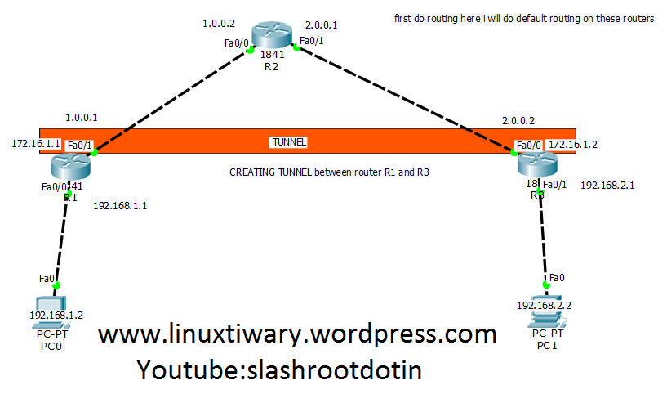

Total network take here are 4.

**network 192.168.1.0/24**

**network 192.168.2.0/24**

**network 1.0.0.0/8**

**network 2.0.0.0/8**

 Now first thing we will do here in this lab is to assign ip address on each and every interface of router and also assign ip address on computers taken here.

CONFIGURATION ON ROUTER R1:

Router>enable

Router#config t

Router(config)#host r1

r1(config)#int fa0/0

r1(config-if)#ip add 192.168.1.1 255.255.255.0

r1(config-if)#no shut

r1(config-if)#exit

r1(config)#int fa0/1

r1(config-if)#ip address 1.0.0.1 255.0.0.0

r1(config-if)#no shut

CONFIGURATION ON ROUTER R2:

Router>enable

Router#config t

Router(config)#host r2

r2(config)#int fa0/0

r2(config-if)#ip add 1.0.0.2 255.0.0.0

r2(config-if)#no shut

r2(config-if)#exit

r2(config)#int fa0/1

r2(config-if)#ip add 2.0.0.1 255.0.0.0

r2(config-if)#no shut

CONFIGURATION ON ROUTER R3:

Router>enable

Router#config t

Router(config)#host r3

r3(config)#int fa0/0

r3(config-if)#ip add 2.0.0.2 255.0.0.0

r3(config-if)#no shut

r3(config-if)#exit

r3(config)#int fa0/1

r3(config-if)#ip add 192.168.2.1 255.255.255.0

r3(config-if)#no shut

**Now its time to do routing. here i am going to configure default routing.**

DEFAULT ROUTING CONFIGURATION ON ROUTER R1:

r1>enable

r1#config t

Enter configuration commands, one per line. End with CNTL/Z.

r1(config)#ip route 0.0.0.0 0.0.0.0 1.0.0.2

r1(config)#

DEFAULT ROUTING CONFIGURATION ON ROUTER R3:

r3>enable

r3#config t

Enter configuration commands, one per line. End with CNTL/Z.

r3(config)#ip route 0.0.0.0 0.0.0.0 2.0.0.1

r3(config)#

NOW CHECK THE CONNECTION BY PINGING EACH OTHER.

**First we go to router r1 and ping with router r3:**

r1#ping 2.0.0.2

Type escape sequence to abort.

Sending 5, 100-byte ICMP Echos to 2.0.0.2, timeout is 2 seconds:

!!!!!

Success rate is 100 percent (5/5), round-trip min/avg/max = 26/28/33 ms

**Now we go to router r3 and test network by pinging router r1 interface.**

r3#ping 1.0.0.1

Type escape sequence to abort.

Sending 5, 100-byte ICMP Echos to 1.0.0.1, timeout is 2 seconds:

!!!!!

Success rate is 100 percent (5/5), round-trip min/avg/max = 25/28/32 ms

You can clearly see both router pinging each other successfully.

NOW CREATE VPN TUNNEL between R1 and R3:

FIRST CREATE A VPN TUNNEL ON ROUTER R1:

r1#config t

r1(config)#interface tunnel 10

r1(config-if)#ip address 172.16.1.1 255.255.0.0

r1(config-if)#tunnel source fa0/1

r1(config-if)#tunnel destination 2.0.0.2

r1(config-if)#no shut

NOW CREATE A VPN TUNNEL ON ROUTER R3:

r3#config t

r3(config)#interface tunnel 100

r3(config-if)#ip address 172.16.1.2 255.255.0.0

r3(config-if)#tunnel source fa0/0

r3(config-if)#tunnel destination 1.0.0.1

r3(config-if)#no shut

**Now test communication between these two routers again by pinging each other:**

1#ping 172.16.1.2

Type escape sequence to abort.

Sending 5, 100-byte ICMP Echos to 172.16.1.2, timeout is 2 seconds:

!!!!!

Success rate is 100 percent (5/5), round-trip min/avg/max = 30/32/36 ms

r1#

r3#ping 172.16.1.1

Type escape sequence to abort.

Sending 5, 100-byte ICMP Echos to 172.16.1.1, timeout is 2 seconds:

!!!!!

Success rate is 100 percent (5/5), round-trip min/avg/max = 33/45/83 ms

Now Do routing for created VPN Tunnel on Both Router R1 and R3:

r1(config)#ip route 192.168.2.0 255.255.255.0 172.16.1.2

r3(config)#ip route 192.168.1.0 255.255.255.0 172.16.1.1

TEST VPN TUNNEL CONFIGURATION:

Now i am going to router R1 and test whether tunnel is created or not.

r1#show interfaces Tunnel 10

Tunnel10 is up, line protocol is up (connected)

Hardware is Tunnel

Internet address is 172.16.1.1/16

MTU 17916 bytes, BW 100 Kbit/sec, DLY 50000 usec,

reliability 255/255, txload 1/255, rxload 1/255

Encapsulation TUNNEL, loopback not set

Keepalive not set

Tunnel source 1.0.0.1 (FastEthernet0/1), destination 2.0.0.2

Tunnel protocol/transport GRE/IP

Key disabled, sequencing disabled

Checksumming of packets disabled

Tunnel TTL 255

Fast tunneling enabled

Tunnel transport MTU 1476 bytes

Tunnel transmit bandwidth 8000 (kbps)

Tunnel receive bandwidth 8000 (kbps)

Last input never, output never, output hang never

Last clearing of "show interface" counters never

Input queue: 0/75/0/0 (size/max/drops/flushes); Total output drops: 1

Queueing strategy: fifo

Output queue: 0/0 (size/max)

5 minute input rate 32 bits/sec, 0 packets/sec

5 minute output rate 32 bits/sec, 0 packets/sec

52 packets input, 3508 bytes, 0 no buffer

Received 0 broadcasts, 0 runts, 0 giants, 0 throttles

0 input errors, 0 CRC, 0 frame, 0 overrun, 0 ignored, 0 abort

0 input packets with dribble condition detected

52 packets output, 3424 bytes, 0 underruns

0 output errors, 0 collisions, 0 interface resets

0 unknown protocol drops

0 output buffer failures, 0 output buffers swapped out

Now going to Router R3 and test VPN Tunnel Creation:

r3#show interface Tunnel 100

Tunnel100 is up, line protocol is up (connected)

Hardware is Tunnel

Internet address is 172.16.1.2/16

MTU 17916 bytes, BW 100 Kbit/sec, DLY 50000 usec,

reliability 255/255, txload 1/255, rxload 1/255

Encapsulation TUNNEL, loopback not set

Keepalive not set

Tunnel source 2.0.0.2 (FastEthernet0/0), destination 1.0.0.1

Tunnel protocol/transport GRE/IP

Key disabled, sequencing disabled

Checksumming of packets disabled

Tunnel TTL 255

Fast tunneling enabled

Tunnel transport MTU 1476 bytes

Tunnel transmit bandwidth 8000 (kbps)

Tunnel receive bandwidth 8000 (kbps)

Last input never, output never, output hang never

Last clearing of "show interface" counters never

Input queue: 0/75/0/0 (size/max/drops/flushes); Total output drops: 1

Queueing strategy: fifo

Output queue: 0/0 (size/max)

5 minute input rate 32 bits/sec, 0 packets/sec

5 minute output rate 32 bits/sec, 0 packets/sec

52 packets input, 3424 bytes, 0 no buffer

Received 0 broadcasts, 0 runts, 0 giants, 0 throttles

0 input errors, 0 CRC, 0 frame, 0 overrun, 0 ignored, 0 abort

0 input packets with dribble condition detected

53 packets output, 3536 bytes, 0 underruns

0 output errors, 0 collisions, 0 interface resets

0 unknown protocol drops

**HOW TO TRACE THE VPN TUNNEL PATH?**

**Now if you want to check what path vpn tunnel is using just go to any of the computer i.e pc and then ping anothr pc located in different network. And then trace the path using tracert. Its result will show the path followed by VPN Tunnel created by you.**

PC>ipconfig

FastEthernet0 Connection:(default port)

Link-local IPv6 Address.........: FE80::2E0:8FFF:FE0B:AEB2

IP Address......................: 192.168.2.2

Subnet Mask.....................: 255.255.255.0

Default Gateway.................: 192.168.2.1

PC>ping 192.168.1.2

Pinging 192.168.1.2 with 32 bytes of data:

Reply from 192.168.1.2: bytes=32 time=61ms TTL=126

Reply from 192.168.1.2: bytes=32 time=55ms TTL=126

Reply from 192.168.1.2: bytes=32 time=55ms TTL=126

Reply from 192.168.1.2: bytes=32 time=57ms TTL=126

Ping statistics for 192.168.1.2:

Packets: Sent = 4, Received = 4, Lost = 0 (0% loss),

Approximate round trip times in milli-seconds:

Minimum = 55ms, Maximum = 61ms, Average = 57ms

PC>tracert 192.168.1.2

Tracing route to 192.168.1.2 over a maximum of 30 hops:

1 3 ms 0 ms 18 ms 192.168.2.1

2 35 ms 30 ms 30 ms 172.16.1.1

3 65 ms 59 ms 60 ms 192.168.1.2

Trace complete.

PC>

Observation and Experiment Analysis

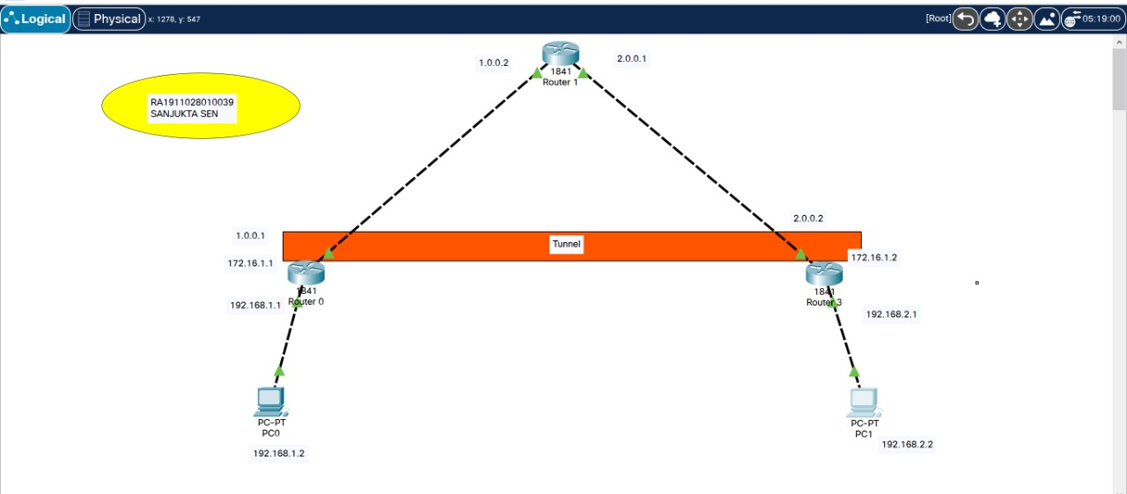

**Router R0 CLI -**

Cisco IOS Software, 1841 Software (C1841-ADVIPSERVICESK9-M), Version 12.4(15)T1, RELEASE SOFTWARE (fc2)

Technical Support: http://www.cisco.com/techsupport

Copyright (c) 1986-2007 by Cisco Systems, Inc.

Compiled Wed 18-Jul-07 04:52 by pt_team

Image text-base: 0x60080608, data-base: 0x6270CD50

This product contains cryptographic features and is subject to United

States and local country laws governing import, export, transfer and

use. Delivery of Cisco cryptographic products does not imply

third-party authority to import, export, distribute or use encryption.

Importers, exporters, distributors and users are responsible for

compliance with U.S. and local country laws. By using this product you

agree to comply with applicable laws and regulations. If you are unable

to comply with U.S. and local laws, return this product immediately.

A summary of U.S. laws governing Cisco cryptographic products may be found at:

http://www.cisco.com/wwl/export/crypto/tool/stqrg.html

If you require further assistance please contact us by sending email to

export@cisco.com.

Cisco 1841 (revision 5.0) with 114688K/16384K bytes of memory.

Processor board ID FTX0947Z18E

M860 processor: part number 0, mask 49

2 FastEthernet/IEEE 802.3 interface(s)

191K bytes of NVRAM.

63488K bytes of ATA CompactFlash (Read/Write)

Cisco IOS Software, 1841 Software (C1841-ADVIPSERVICESK9-M), Version 12.4(15)T1, RELEASE SOFTWARE (fc2)

Technical Support: http://www.cisco.com/techsupport

Copyright (c) 1986-2007 by Cisco Systems, Inc.

Compiled Wed 18-Jul-07 04:52 by pt_team

--- System Configuration Dialog ---

Would you like to enter the initial configuration dialog? [yes/no]: n

Press RETURN to get started!

Router>enable

Router#

Router#configure terminal

Enter configuration commands, one per line. End with CNTL/Z.

Router(config)#interface FastEthernet0/0

Router(config-if)#ip address 192.168.1.1 255.255.255.0

Router(config-if)#no shutdown

Router(config-if)#

%LINK-5-CHANGED: Interface FastEthernet0/0, changed state to up

%LINEPROTO-5-UPDOWN: Line protocol on Interface FastEthernet0/0, changed state to up

Router(config-if)#exit

Router(config)#interface FastEthernet0/1

Router(config-if)#ip address 1.0.0.1 255.0.0.0

Router(config-if)#no shutdown

Router(config-if)#

%LINK-5-CHANGED: Interface FastEthernet0/1, changed state to up

Router(config-if)#exit

Router(config)#interface FastEthernet0/0

Router(config-if)#

Router(config-if)#exit

Router(config)#interface FastEthernet0/1

Router(config-if)#

%LINEPROTO-5-UPDOWN: Line protocol on Interface FastEthernet0/1, changed state to up

Router(config-if)#

Router(config-if)#

Router(config-if)#exit

Router(config)#

Router(config)#exit

Router#

%SYS-5-CONFIG_I: Configured from console by console

Router#ping 2.0.0.2

Type escape sequence to abort.

Sending 5, 100-byte ICMP Echos to 2.0.0.2, timeout is 2 seconds:

.....

Success rate is 0 percent (0/5)

Router#en

Router#conf t

Enter configuration commands, one per line. End with CNTL/Z.

Router(config)#ip route 0.0.0.0 0.0.0.0 1.0.0.2

Router(config)#ping 2.0.0.2

^

% Invalid input detected at '^' marker.

Router(config)#exit

Router#

%SYS-5-CONFIG_I: Configured from console by console

Router#ping 2.0.0.2

Type escape sequence to abort.

Sending 5, 100-byte ICMP Echos to 2.0.0.2, timeout is 2 seconds:

..!!!

Success rate is 60 percent (3/5), round-trip min/avg/max = 0/0/1 ms

Router#ping 2.0.0.2

Type escape sequence to abort.

Sending 5, 100-byte ICMP Echos to 2.0.0.2, timeout is 2 seconds:

!!!!!

Success rate is 100 percent (5/5), round-trip min/avg/max = 0/0/1 ms

Router#ping 2.0.0.2

Type escape sequence to abort.

Sending 5, 100-byte ICMP Echos to 2.0.0.2, timeout is 2 seconds:

!!!!!

Success rate is 100 percent (5/5), round-trip min/avg/max = 0/0/0 ms

Router#conf t

Enter configuration commands, one per line. End with CNTL/Z.

Router(config)#interface tunnel 10

Router(config-if)#

%LINK-5-CHANGED: Interface Tunnel10, changed state to up

Router(config-if)#ip address 172.16.1.1 255.255.0.0

Router(config-if)#tunnel source fa0/1

Router(config-if)#tunnel destination 2.0.0.2

Router(config-if)#

%LINEPROTO-5-UPDOWN: Line protocol on Interface Tunnel10, changed state to up

Router(config-if)#no shut

Router(config-if)#exit

Router(config)#exit

Router#

%SYS-5-CONFIG_I: Configured from console by console

Router#ping 172.16.1.2

Type escape sequence to abort.

Sending 5, 100-byte ICMP Echos to 172.16.1.2, timeout is 2 seconds:

..!!!

Success rate is 60 percent (3/5), round-trip min/avg/max = 0/0/1 ms

Router#ping 172.16.1.2

Type escape sequence to abort.

Sending 5, 100-byte ICMP Echos to 172.16.1.2, timeout is 2 seconds:

!!!!!

Success rate is 100 percent (5/5), round-trip min/avg/max = 0/0/1 ms

Router#ip route 192.168.2.0 255.255.255.0 172.16.1.2

^

% Invalid input detected at '^' marker.

Router#conf t

Enter configuration commands, one per line. End with CNTL/Z.

Router(config)#ip route 192.168.2.0 255.255.255.0 172.16.1.2

Router(config)#exit

Router#

%SYS-5-CONFIG_I: Configured from console by console

Router#show interfaces Tunnel 10

Tunnel10 is up, line protocol is up (connected)

Hardware is Tunnel

Internet address is 172.16.1.1/16

MTU 17916 bytes, BW 100 Kbit/sec, DLY 50000 usec,

reliability 255/255, txload 1/255, rxload 1/255

Encapsulation TUNNEL, loopback not set

Keepalive not set

Tunnel source 1.0.0.1 (FastEthernet0/1), destination 2.0.0.2

Tunnel protocol/transport GRE/IP

Key disabled, sequencing disabled

Checksumming of packets disabled

Tunnel TTL 255

Fast tunneling enabled

Tunnel transport MTU 1476 bytes

Tunnel transmit bandwidth 8000 (kbps)

Tunnel receive bandwidth 8000 (kbps)

Last input never, output never, output hang never

Last clearing of "show interface" counters never

Input queue: 0/75/0/0 (size/max/drops/flushes); Total output drops: 1

Queueing strategy: fifo

Output queue: 0/0 (size/max)

5 minute input rate 17 bits/sec, 0 packets/sec

5 minute output rate 0 bits/sec, 0 packets/sec

13 packets input, 1664 bytes, 0 no buffer

Received 0 broadcasts, 0 runts, 0 giants, 0 throttles

0 input errors, 0 CRC, 0 frame, 0 overrun, 0 ignored, 0 abort

0 input packets with dribble condition detected

0 packets output, 0 bytes, 0 underruns

0 output errors, 0 collisions, 0 interface resets

0 unknown protocol drops

0 output buffer failures, 0 output buffers swapped out

Router#

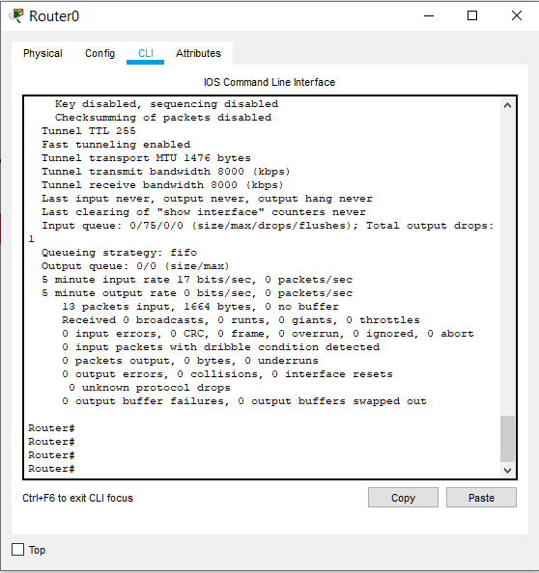

**Router R3 CLI –**

System Bootstrap, Version 12.3(8r)T8, RELEASE SOFTWARE (fc1)

Cisco 1841 (revision 5.0) with 114688K/16384K bytes of memory.

Readonly ROMMON initialized

Self decompressing the image :

########################################################################## [OK]

Restricted Rights Legend

Use, duplication, or disclosure by the Government is

subject to restrictions as set forth in subparagraph

(c) of the Commercial Computer Software - Restricted

Rights clause at FAR sec. 52.227-19 and subparagraph

(c) (1) (ii) of the Rights in Technical Data and Computer

Software clause at DFARS sec. 252.227-7013.

cisco Systems, Inc.

170 West Tasman Drive

San Jose, California 95134-1706

Cisco IOS Software, 1841 Software (C1841-ADVIPSERVICESK9-M), Version 12.4(15)T1, RELEASE SOFTWARE (fc2)

Technical Support: http://www.cisco.com/techsupport

Copyright (c) 1986-2007 by Cisco Systems, Inc.

Compiled Wed 18-Jul-07 04:52 by pt_team

Image text-base: 0x60080608, data-base: 0x6270CD50

This product contains cryptographic features and is subject to United

States and local country laws governing import, export, transfer and

use. Delivery of Cisco cryptographic products does not imply

third-party authority to import, export, distribute or use encryption.

Importers, exporters, distributors and users are responsible for

compliance with U.S. and local country laws. By using this product you

agree to comply with applicable laws and regulations. If you are unable

to comply with U.S. and local laws, return this product immediately.

Cisco 1841 (revision 5.0) with 114688K/16384K bytes of memory.

Processor board ID FTX0947Z18E

M860 processor: part number 0, mask 49

2 FastEthernet/IEEE 802.3 interface(s)

191K bytes of NVRAM.

63488K bytes of ATA CompactFlash (Read/Write)

Cisco IOS Software, 1841 Software (C1841-ADVIPSERVICESK9-M), Version 12.4(15)T1, RELEASE SOFTWARE (fc2)

Technical Support: http://www.cisco.com/techsupport

Copyright (c) 1986-2007 by Cisco Systems, Inc.

Compiled Wed 18-Jul-07 04:52 by pt_team

--- System Configuration Dialog ---

Would you like to enter the initial configuration dialog? [yes/no]: n

Press RETURN to get started!

Router>enable

Router#

Router#configure terminal

Enter configuration commands, one per line. End with CNTL/Z.

Router(config)#interface FastEthernet0/0

Router(config-if)#ip address 2.0.0.2 255.0.0.0

Router(config-if)#no shutdown

Router(config-if)#

%LINK-5-CHANGED: Interface FastEthernet0/0, changed state to up

%LINEPROTO-5-UPDOWN: Line protocol on Interface FastEthernet0/0, changed state to up

Router(config-if)#exit

Router(config)#interface FastEthernet0/1

Router(config-if)#ip address 192.168.2.1 255.255.255.0

Router(config-if)#no shutdown

Router(config-if)#

%LINK-5-CHANGED: Interface FastEthernet0/1, changed state to up

%LINEPROTO-5-UPDOWN: Line protocol on Interface FastEthernet0/1, changed state to up

Router(config-if)#exit

Router(config)#interface FastEthernet0/0

Router(config-if)#

Router(config-if)#

Router(config-if)#exit

Router(config)#exit

Router#

%SYS-5-CONFIG_I: Configured from console by console

Router#en

Router#conf t

Enter configuration commands, one per line. End with CNTL/Z.

Router(config)#ip route 0.0.0.0 0.0.0.0 2.0.0.1

Router(config)#exit

Router#

%SYS-5-CONFIG_I: Configured from console by console

Router#ping 1.0.0.1

Type escape sequence to abort.

Sending 5, 100-byte ICMP Echos to 1.0.0.1, timeout is 2 seconds:

.!!!!

Success rate is 80 percent (4/5), round-trip min/avg/max = 0/0/2 ms

Router#ping 1.0.0.1

Type escape sequence to abort.

Sending 5, 100-byte ICMP Echos to 1.0.0.1, timeout is 2 seconds:

!!!!!

Success rate is 100 percent (5/5), round-trip min/avg/max = 0/0/0 ms

Router#conf t

Enter configuration commands, one per line. End with CNTL/Z.

Router(config)#interface tunnel 100

Router(config-if)#

%LINK-5-CHANGED: Interface Tunnel100, changed state to up

Router(config-if)#ip address 172.16.1.2 255.255.0.0

Router(config-if)#tunnel source fa0/0

Router(config-if)#tunnel destination 1.0.0.1

Router(config-if)#

%LINEPROTO-5-UPDOWN: Line protocol on Interface Tunnel100, changed state to up

Router(config-if)#no shut

Router(config-if)#exit

Router(config)#

Router(config)#exit

Router#

%SYS-5-CONFIG_I: Configured from console by console

Router#ping 172.16.1.1

Type escape sequence to abort.

Sending 5, 100-byte ICMP Echos to 172.16.1.1, timeout is 2 seconds:

!!!!!

Success rate is 100 percent (5/5), round-trip min/avg/max = 0/0/1 ms

Router#conf t

Enter configuration commands, one per line. End with CNTL/Z.

Router(config)#ip route 192.168.1.0 255.255.255.0 172.16.1.1

Router(config)#exit

Router#

%SYS-5-CONFIG_I: Configured from console by console

Router#show interfaces Tunnel 100

Tunnel100 is up, line protocol is up (connected)

Hardware is Tunnel

Internet address is 172.16.1.2/16

MTU 17916 bytes, BW 100 Kbit/sec, DLY 50000 usec,

reliability 255/255, txload 1/255, rxload 1/255

Encapsulation TUNNEL, loopback not set

Keepalive not set

Tunnel source 2.0.0.2 (FastEthernet0/0), destination 1.0.0.1

Tunnel protocol/transport GRE/IP

Key disabled, sequencing disabled

Checksumming of packets disabled

Tunnel TTL 255

Fast tunneling enabled

Tunnel transport MTU 1476 bytes

Tunnel transmit bandwidth 8000 (kbps)

Tunnel receive bandwidth 8000 (kbps)

Last input never, output never, output hang never

Last clearing of "show interface" counters never

Input queue: 0/75/0/0 (size/max/drops/flushes); Total output drops: 1

Queueing strategy: fifo

Output queue: 0/0 (size/max)

5 minute input rate 23 bits/sec, 0 packets/sec

5 minute output rate 0 bits/sec, 0 packets/sec

14 packets input, 1792 bytes, 0 no buffer

Received 0 broadcasts, 0 runts, 0 giants, 0 throttles

0 input errors, 0 CRC, 0 frame, 0 overrun, 0 ignored, 0 abort

0 input packets with dribble condition detected

0 packets output, 0 bytes, 0 underruns

0 output errors, 0 collisions, 0 interface resets

0 unknown protocol drops

0 output buffer failures, 0 output buffers swapped out

Router#

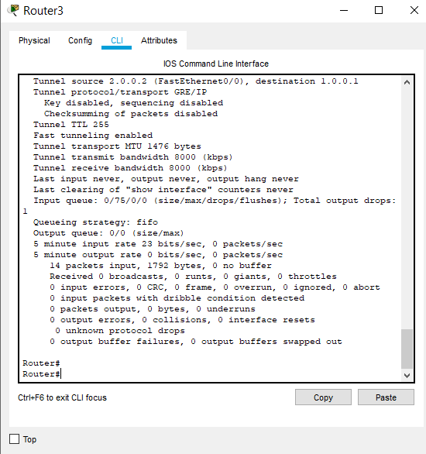

**Pinging PC1 with PC0 –**

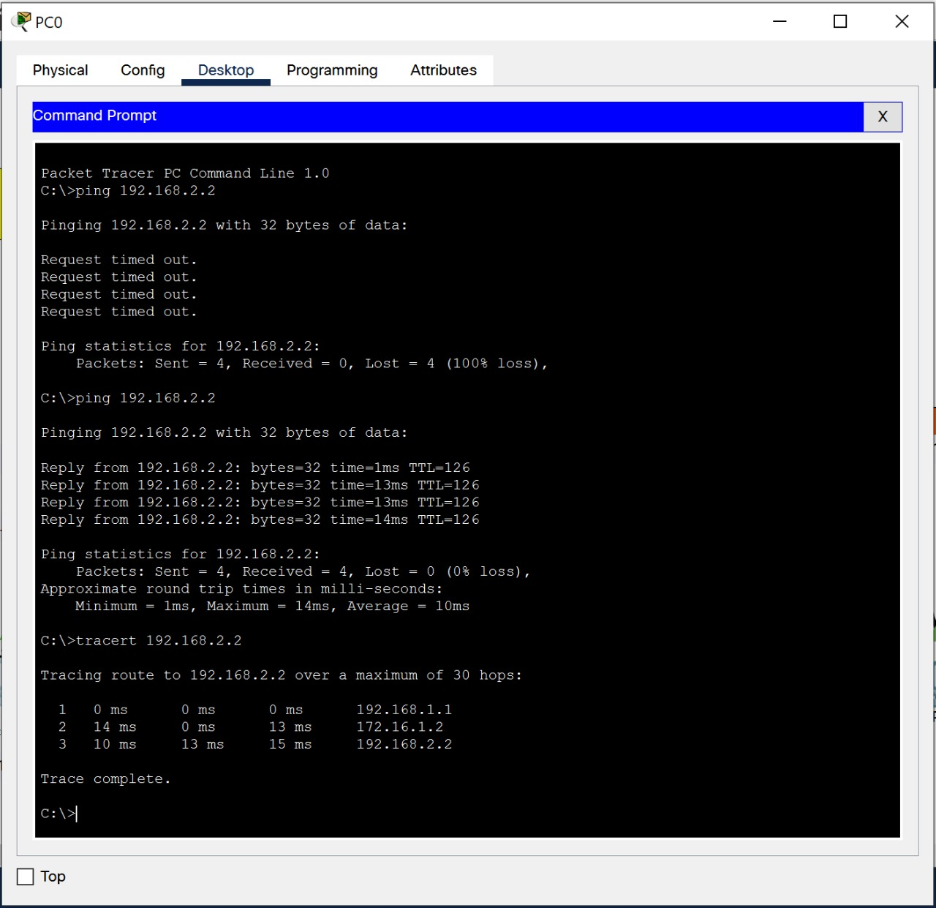

**Pinging PC0 with PC1-**

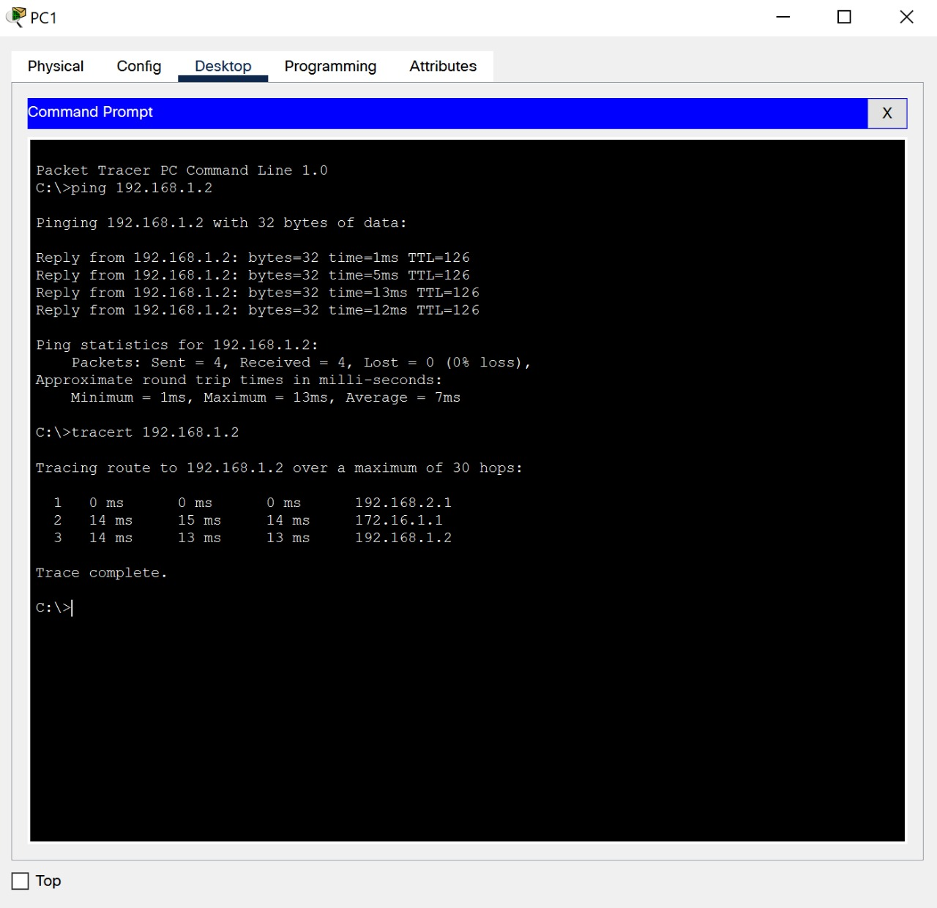

Result:

Virtual Private Network (VPN) was successfully built and implemented.